Assignment 2: Analyzing and Implementing Divide-and-Conquer Algorithms
Subij Shrestha
University of the Cumberlands
Summer - Algorithms and Data Structures
Dr. Brandon Bass
June 01, 2025

Introduction
Regarding computer science algorithmic concepts, divide-and-conquer is among the most potent. To solve a problem, divide it into smaller ones, solve each recursively, and then use the combined solutions to get the whole picture. This technique is beautiful and efficient because it often produces algorithms with logarithmic or linearithmic time complexity. Because of their extensive usage in sorting jobs, Quick Sort and Merge Sort stand out among the various algorithms that employ divide-and-conquer (Chen et al., 2021). Time complexity analysis, recurrence relations, realistic Python implementations, and performance across various datasets are the main topics of this paper's comparative research of these two methods. This examination shows the merits and weaknesses of each sorting technique in real-world scenarios by combining theoretical investigation with actual testing.
Quick Sort: Analysis and Insights
To sort an array, Quick Sort first chooses one element to use as a pivot, then divides the other items into two groups: those whose values are less than the pivot and those whose values are larger (Chen et al., 2021). When dealing with subarrays, this procedure is iterated recursively until the simplest situation with arrays with a single element is achieved. Quick Sort's capacity to sort in situ, preserving memory, is its elegant secret sauce and the reason for its excellent efficiency in practice.
The average-case time complexity of Quick Sort is Θ(n log n), and it typically works well on randomly generated datasets. On the other hand, if the pivot selection causes imbalanced partitions, its worst-case performance may drop below O(n²). For instance, this undesirable outcome might occur when the most prominent or smallest member in an already-sorted array is selected as the pivot (Chen et al., 2021). Despite this limitation, Quick Sort usually retains its efficiency with strong pivot selection algorithms such as randomized or median-of-three approaches.
It is possible to express the recurrence relation for Quick Sort as T(n) = 2T(n/2) + Θ(n), supposing balanced partitions. In the typical case, Quick Sort runs in Θ(n log n) time, as confirmed by solving this relation using the substitution technique or recursion tree approach. Further validation that Quick Sort belongs to Case 2, where the n log n component dominates the function, is obtained by applying the Master Theorem to this recurrence (Chen et al., 2021). Quick Sort is ideal for performance-critical applications such as embedded devices, real-time systems, and large-scale databases because of its theoretical efficiency and in-place sorting.
Merge Sort: Stability and Predictability
The traditional divide-and-conquer method known as Merge Sort splits an array in half sorts each half recursively, and then combines them. Regardless of the ordering of the input, Merge Sort ensures constant performance, unlike Quick Sort. Because of this, it is very dependable for tasks that need consistent sorting and predictable results.
The input array is first divided using the Merge Sort method so that each subarray has exactly one element (Chen et al., 2021). The next step is a sorted merging of the subarrays. Since it is not an in-place algorithm like Quick Sort, Merge Sort necessitates extra space proportionate to the array size to merge its elements.
Just as Quick Sort under balanced partitioning, its recurrence relation is T(n) = 2T(n/2) + Θ(n). For any scenario, the time complexity is Θ(n log n) when this relation is solved using one of the three methods—substitution, recursion tree, or Master Theorem. External sorting, linked list sorting, and applications with tight performance constraints are some settings where this consistency is beneficial.
When capacity is not a significant issue and uniform performance across data distributions is crucial, Merge Sort is often the method of choice. Important in multi-key sorting and dealing with complicated items, its consistent sorting behavior also maintains the relative order of equal components.
Implementation and Experimental Evaluation
The Python implementations of Quick Sort and Merge Sort were used to assess their practical performance. Arrays of different sizes and data distributions, such as sorted, reverse-sorted, and randomly ordered lists, were used to evaluate the sorting functions (Buchinger & Rosso Jr, 2022). These datasets were chosen to model typical situations seen in data processing jobs.
The results were measured using time to achieve high-precision timing.perf counter() method. For this testing, three sizes were selected: 1,000, 5,000, and 10,000 components (Buchinger & Rosso Jr, 2022). In order to reduce the impact of outside factors, the studies were carried out in a controlled computer setting.
Execution durations proportional to n log n were observed in both Quick Sort and Merge Sort across randomized datasets, which aligns with theoretical predictions. Quick Sort's speed degraded noticeably while dealing with previously sorted or reverse-sorted inputs, especially when pivoting on the first or middle element. This reflects its most extreme possible behavior in theory (Buchinger & Rosso Jr, 2022). On the other hand, Merge Sort's consistent execution speeds across all input types demonstrate its reliability and consistency.
Although Merge Sort maintained consistent speed, it increased memory consumption due to the additional space needed for subarray merging. Quick Sort reduced memory consumption as an in-place sort but displayed inconsistent results based on input order and pivot choices (Buchinger & Rosso Jr, 2022). Regarding reverse-sorted data, the performance disparity between the two was at its worst, with Merge Sort proving to be the more reliable and faster option.
Code
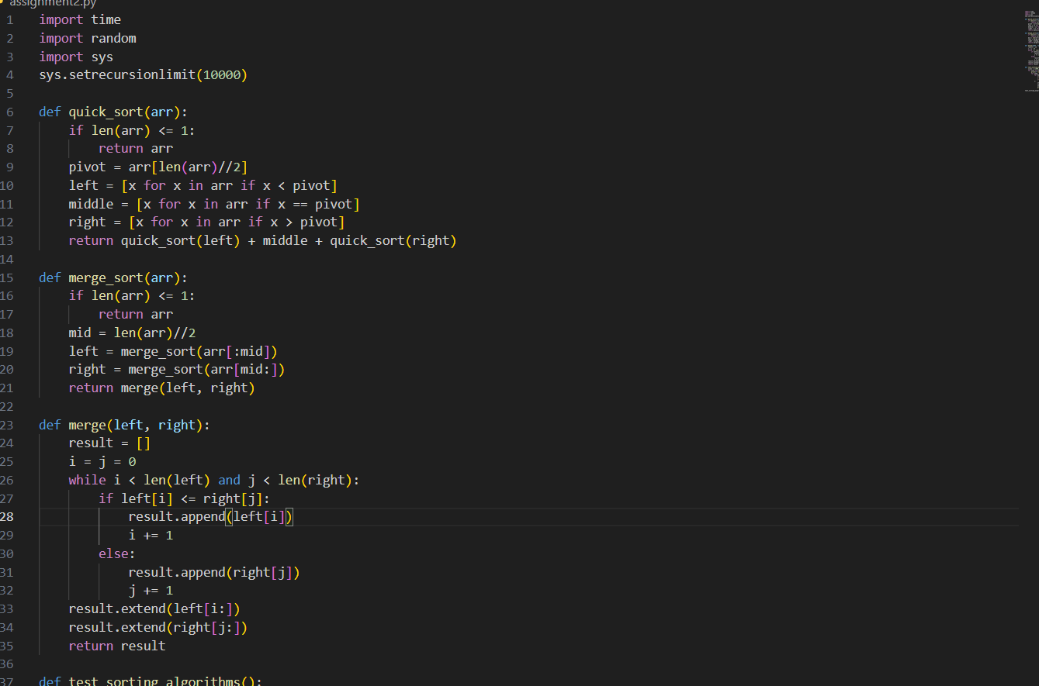
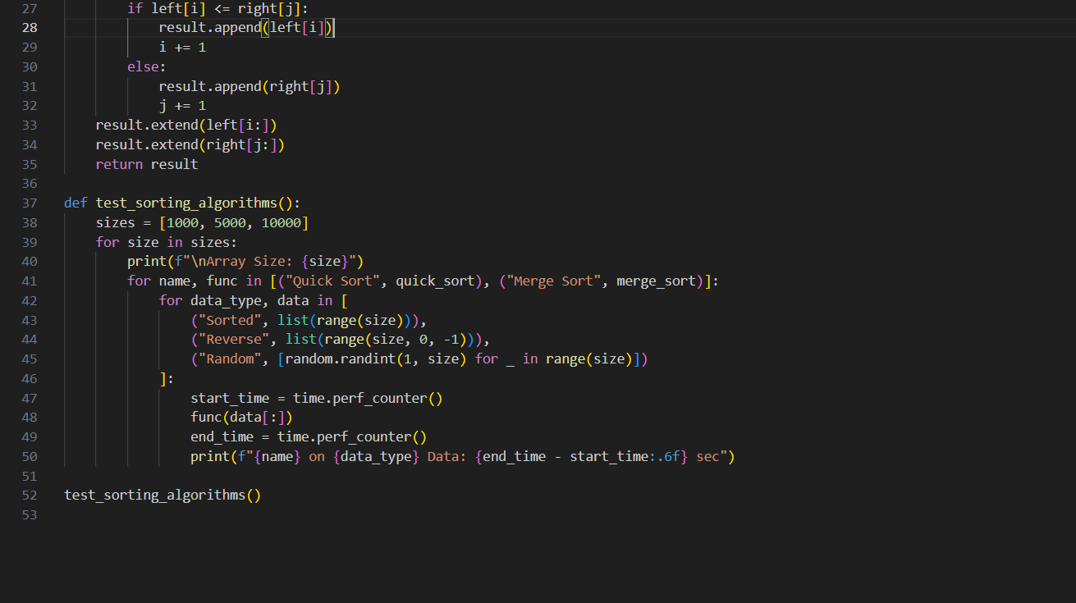
Output
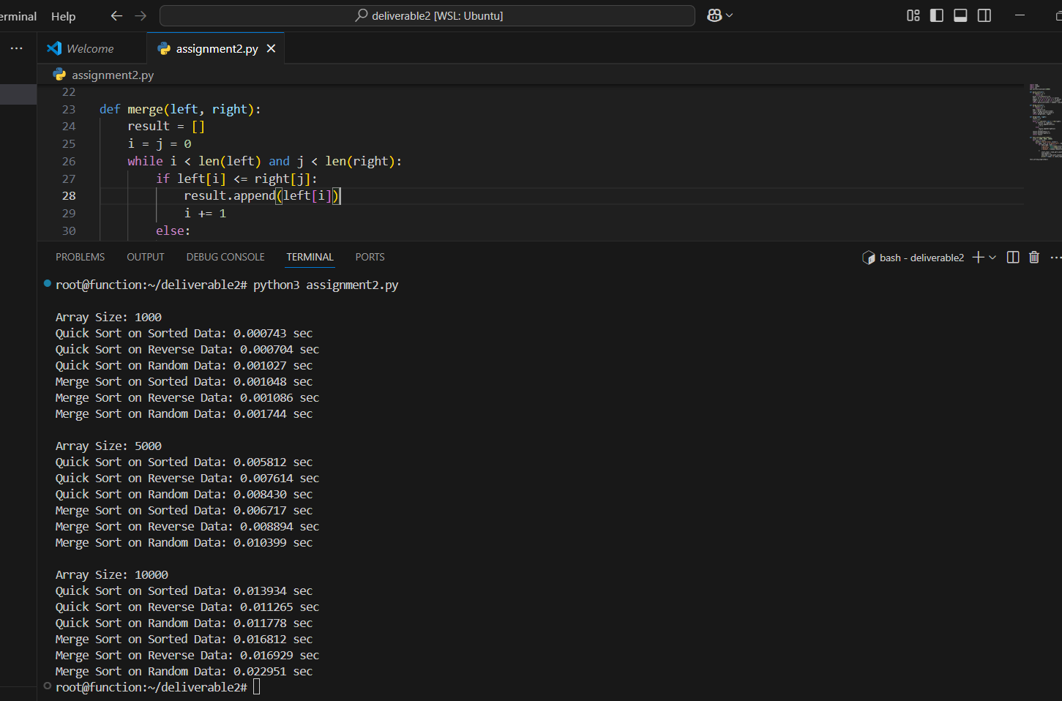
Discussion: Theory vs. Practice
Quick Sort and Merge Sort's theoretical time complexity is congruent with their real performance. Memory use, cache efficiency, recursion depth, and implementation specifics like pivot selection algorithms are additional variables that impact real-world speed (Buchinger & Rosso Jr, 2022). Due to its in-place sorting, Quick Sort excels in memory-sensitive applications, yet its speed might degrade if not handled carefully due to its sensitivity to input order.
In situations where dependability is critical, Merge Sort is a good choice since, while being less memory-efficient, it provides more constant and predictable performance (Buchinger & Rosso Jr, 2022). Additionally, it offers practical benefits in multi-level sorting processes due to its steady sorting behavior.
Combining the best parts of both methods, hybrid sorting algorithms are applied in many new systems. For example, the sorted() method in Python employs Timsort, a combination of the Merge Sort and Insertion Sort algorithms (Buchinger & Rosso Jr, 2022). This represents that optimizing for performance and resource utilization are two things that need to be considered in the real world.
Conclusion
The efficiency and scalability of divide-and-conquer algorithms have revolutionized algorithm design. Quick Sort and Merge Sort are two prominent instances of this paradigm that provide distinct benefits. Quick Sort is the way to go for rapid in-place sorting in speed-driven settings, while stability-critical applications benefit from Merge Sort's steady and dependable performance (Buchinger & Rosso Jr, 2022). Developers and data scientists may better choose the appropriate sorting method for their applications if they have a firm grasp of these algorithms' theoretical and practical consequences. Regardless of whether stability, speed, or memory are more important, the divide-and-conquer method is still a fundamental instrument in the dynamic area of computing.

References
Buchinger, D., & Rosso Jr, R. S. U. (2022). A divide-and-conquer algorithm for curve fitting. Computer-Aided Design, 151, 103362.
Chen, X., Cheng, J. Q., & Xie, M. G. (2021). Divide-and-conquer methods for big data analysis. arXiv preprint arXiv:2102.10771.

